**Mineral Resources Lab Report**

**Rishabh Gupta | 16GG20022**

The following graphs were produced using PG2000. I explored various graph forms for geostatistics data.

Broomsbarn data Histogram with Normal Model of pH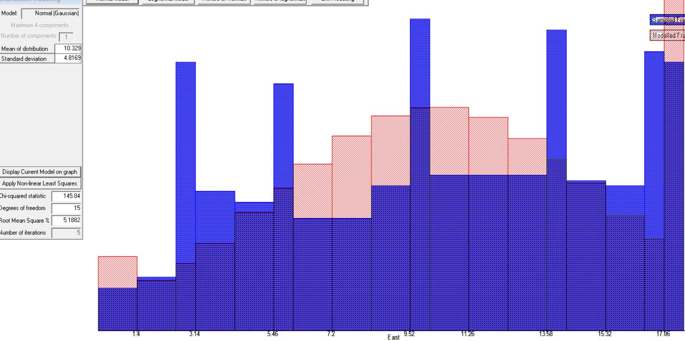

Broomsbarn data plot of logK with probability plot with lognormal model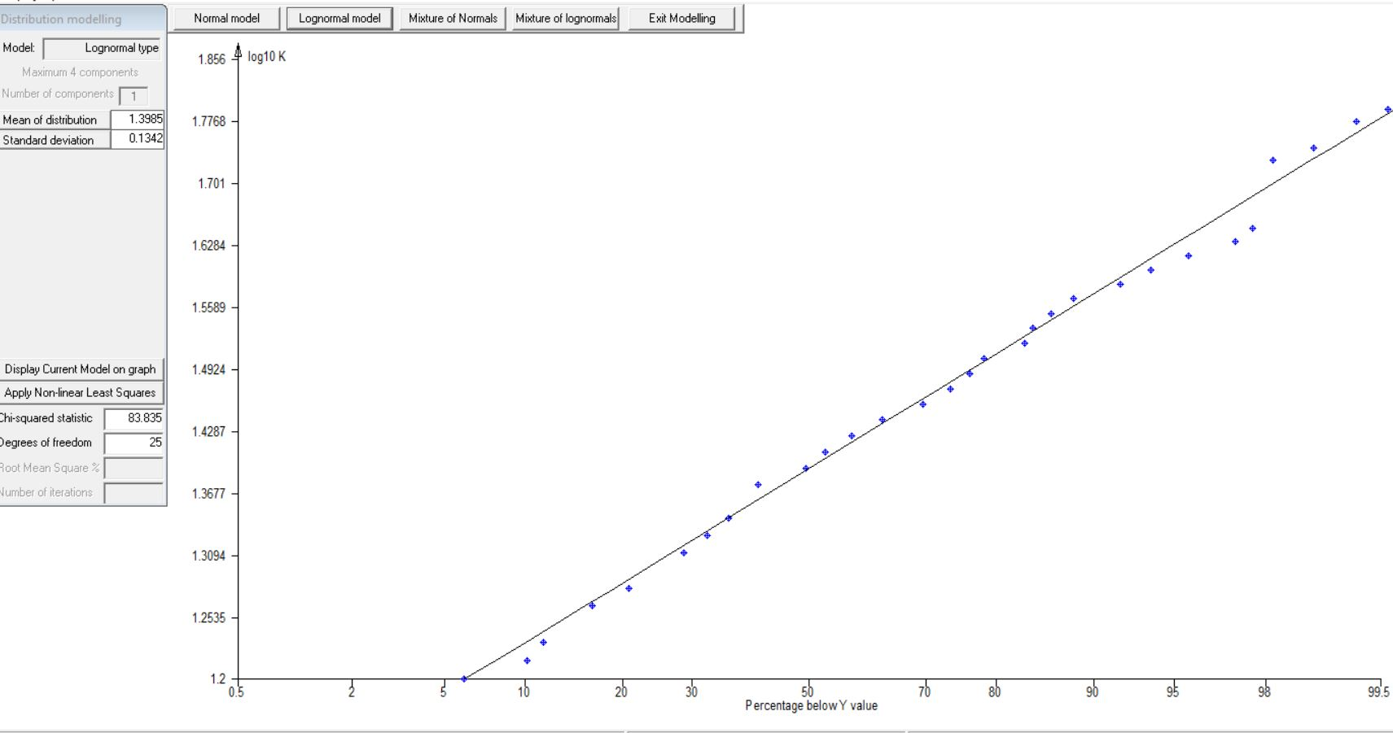

Broomsbarn data Histogram with LogNormal Model of logK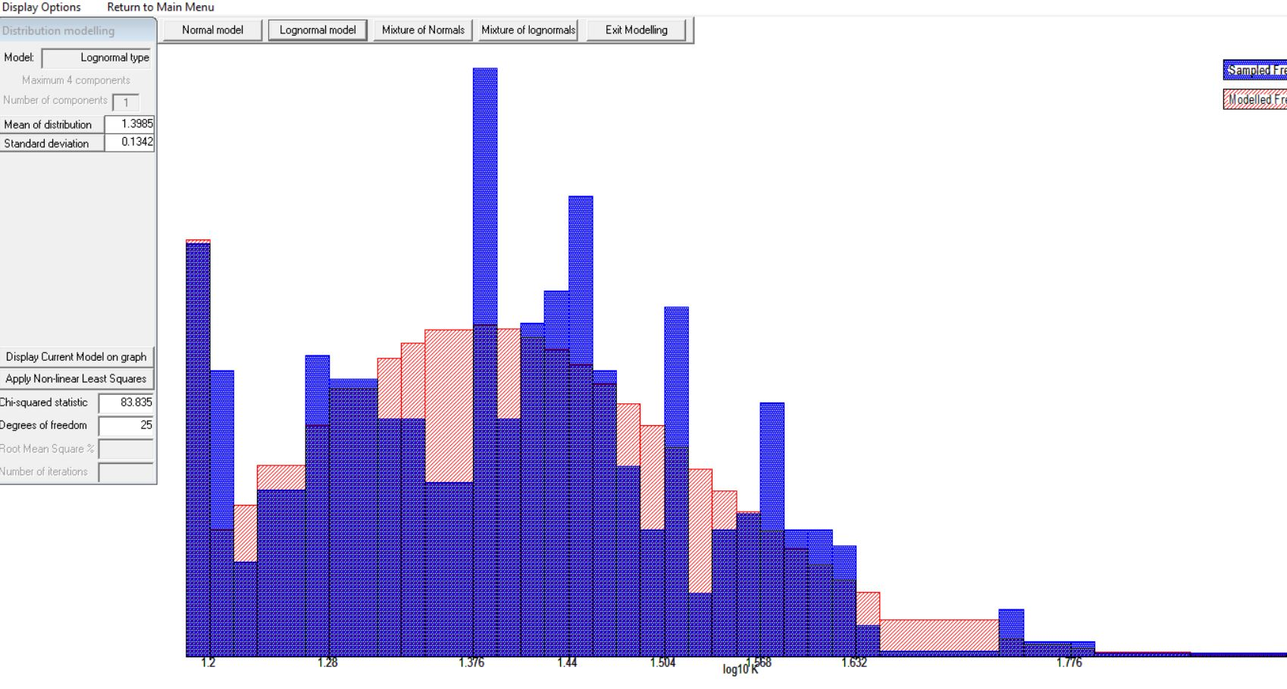

Broomsbarn data Histogram with Normal Model of logK

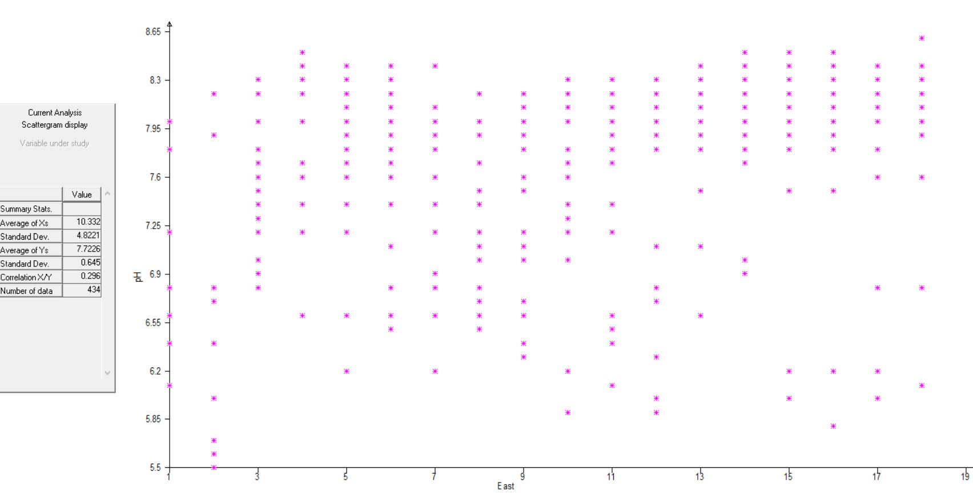

Broomsbarn data scatterplot of Potentiometric value vs East value

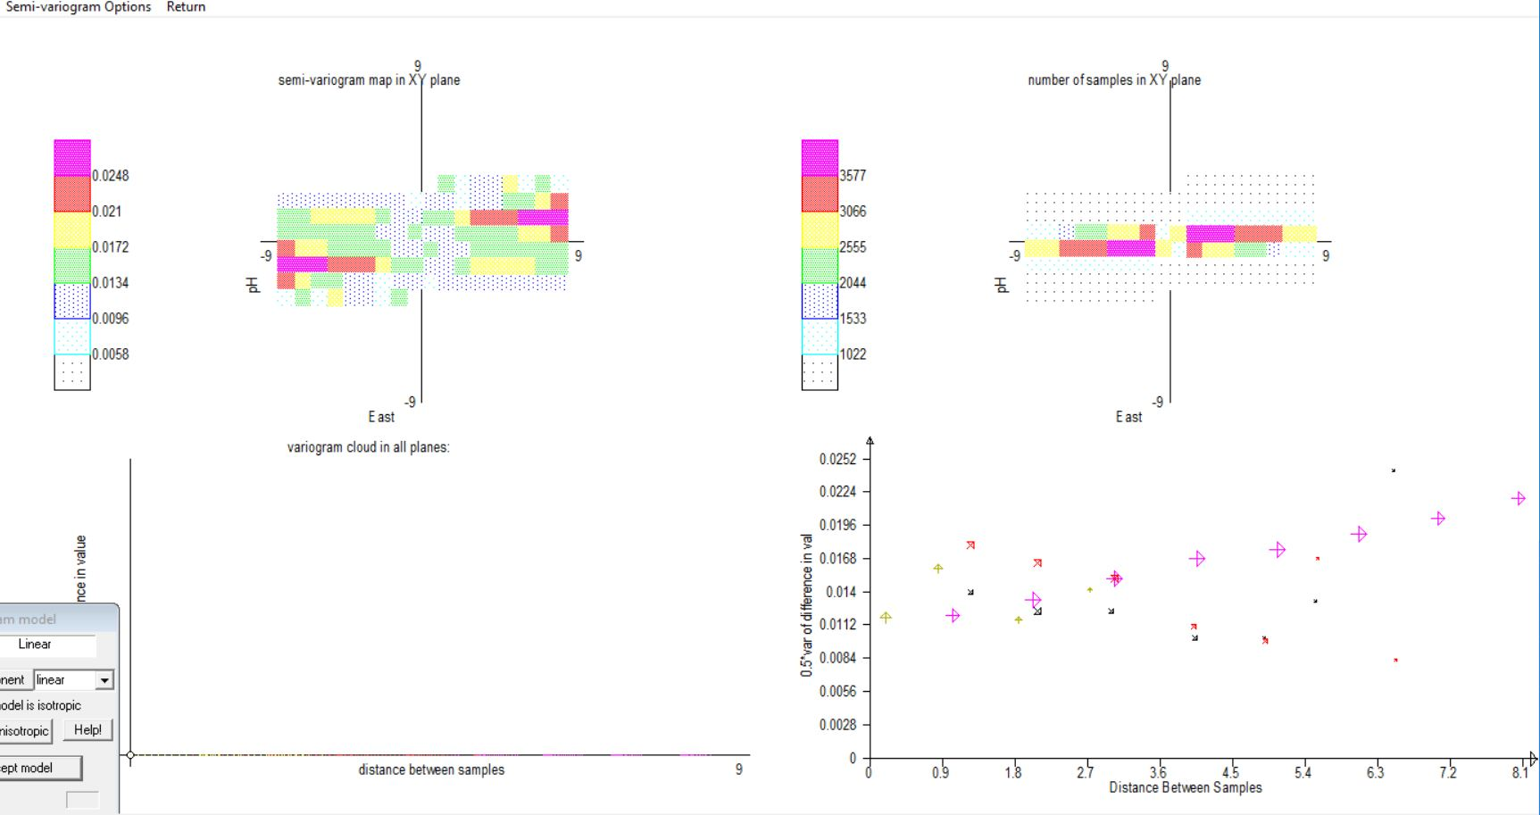

Bloomsbarn data Semi variogram of pH and East value

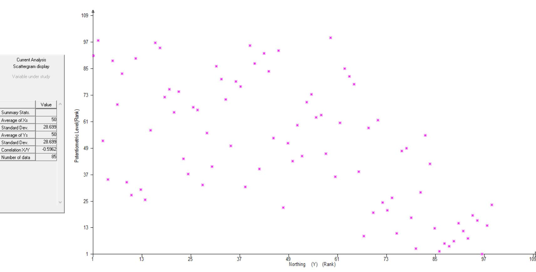

WOLFCAMP data scatter plot potentiometer vs North

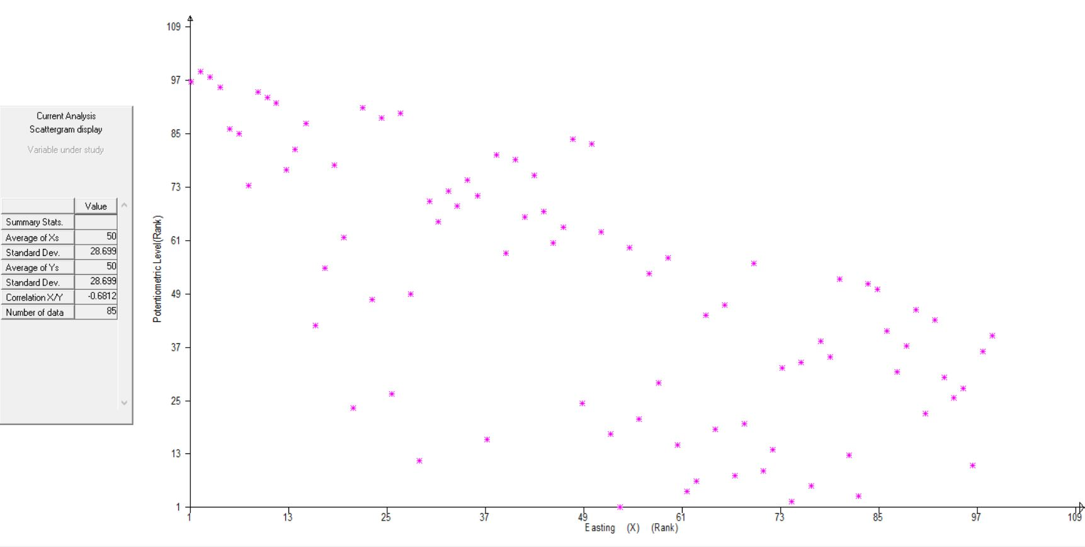

WOLFCAMP data scatterplot potentiometer vs easting